**CFG rules**

1 - Write a CFG for accepting strings with equal number of a's and b's.

S -> aSb | bSa | ba | ab | ε

2- Write a CFG for accepting strings where the number of b's is twice the number of a's.

S -> bba | abb | aSbb | bbSa | ε

3- Write a CFG for accepting strings that is not a palindrome Σ = {a,b}.

S -> aSa | bSb | aTb | bTa,

T -> aT | bT | ε

4- Write a CFG for accepting a language {𝑎 2𝑛 +3 𝑏 𝑛 | n>=0}.

S -> aaaT,

T-> aaTb | ε

5- Write a CFG for accepting a language {𝑎 n 𝑏 m| n>m and m>=0}.

S -> aS | aB,

B -> aBb | ε

**PDA**

1. Design a PDA for accepting a language {anbmcn|n,m>=0}.

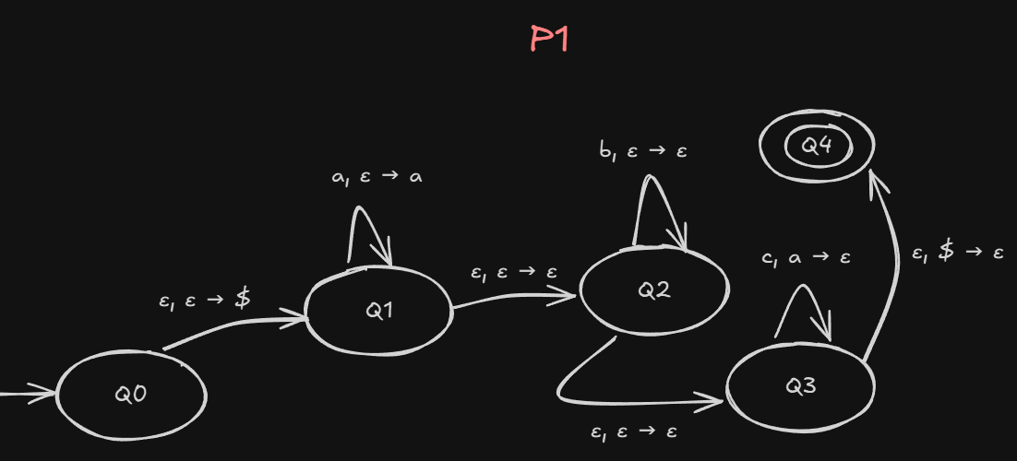

1. Design a PDA for accepting a language {a3nb2n n>=1}.

1. Design a PDA for accepting a language that consists of strings of balanced

1. Design a PDA for accepting a language {anbn+mcm| n , m>=1}.

1. Design a PDA for language {Wck | W ∈ {a,b}* and n >=0 and k = |W|b (k=the number of b in W)}.

**BONUS - Convert the following CFG to PDA:**

